### AIS VHF Antenna, Amphenol Procom 2 element Yagi 156-175 MHz

AIS VHF Antenna will be connected to AIS BS Controller and VHF DSC Radio by Band Pass Filter.

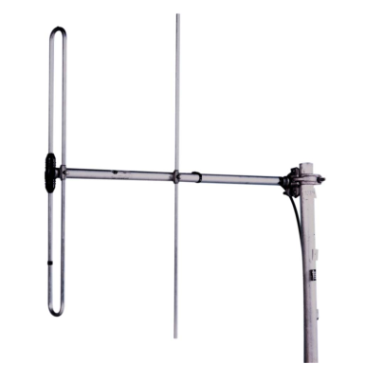

Figure 3‑3 AIS VHF Antenna Amphenol Procom 2 element Yagi 156-175 MHz

For transmitting and receiving purposes of AIS Base Station use VHF Antennas manufactured by Procom.

|  |  |
| --- | --- |
| **General Specification** | |
| Antenna type | 2-element Yagi |
| Frequency | 156-175 MHz |
| Impedance | Nom. 50 Ω |
| Polarization | Vertical or Horizontal |
| Gain | 5.2dBi 3dBd |
| Front to back ratio | >12dBd |
| Half-power beamwidth | E-Plane: 750, H-Plane: 1500 |
| VSWR | ≤1.5:1 |
| Max. power | 150W |
| Antistatic Protection | All metal parts DS-grounded (Connector shows a DC-short) |
| Connection | 3m tail of RG213 terminated with N-female connector |
| Wind Survival Speed | 200 km/h |
| Materials | Elements/Boom/Saddle clamps: Aluminium alloys. Fittings: Stainless steel |
| Boom dia. | 32 mm |
| Element length | 870mm |
| Dia. Of elements | 19.1 mm |
| Weight | Approx. 2.1 kg |
| Mounting | Supplied with mast bracket suiting 30-58 mm dia. mast tube |